Develop MetaFabric Back end
Follow this: https://chatgpt.com/g/g-p-6adb70a301b881918f3573c2e283e8be-meta-ai-competition/c/6ae63126-1cc0-83e9-a91c-dea38789302e
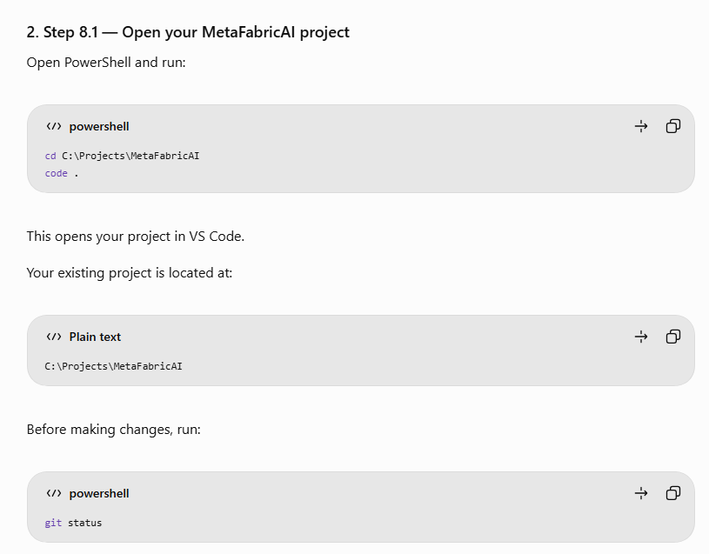

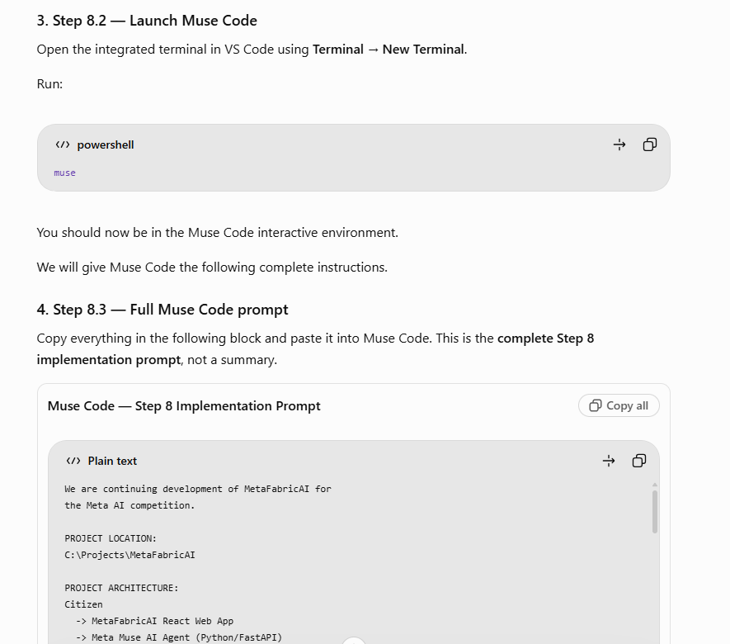

====Detailed Prompt ========
We are continuing development of MetaFabricAI for the Meta AI competition.

PROJECT LOCATION:
C:\Projects\MetaFabricAI

PROJECT ARCHITECTURE:
Citizen
-> MetaFabricAI React Web App
-> Meta Muse AI Agent (Python/FastAPI)
-> FastMCP Client
-> Azure Metadata MCP Server
-> Open Data Metadata Catalog

CURRENT STATUS:
Step 7, the React + TypeScript + Vite + Tailwind
frontend dashboard, is completed.

Preserve all existing frontend code, layout,
dashboard, dataset cards, Data Recipe interface,
and visual workflow.

OBJECTIVE:
Implement Step 8: Create a Python FastAPI backend
and reusable asynchronous FastMCP client.

AZURE MCP ENDPOINT:
https://ca-metadata-mcp-dev.wittyforest-26c063ae.eastus.azurecontainerapps.io/mcp

EXISTING MCP TOOLS:
1. get_metadata_fields
2. get_metadata_field_definitions
3. get_metadata_catalog
4. get_layer_metadata

TASK 1 — INSPECT THE PROJECT
Inspect the current files and Git repository.
Do not modify the existing React frontend.

TASK 2 — CREATE BACKEND FILES
Create the following structure:

backend/
app/
__init__.py
main.py
config.py
services/
__init__.py
mcp_client.py
routers/
__init__.py
health.py
scripts/
test_mcp_connection.py
tests/
requirements.txt
.env.example
README.md

Keep the structure extensible for a future
backend/app/agents/ Muse AI agent implementation.

TASK 3 — CREATE REQUIREMENTS
Include:
fastapi
uvicorn[standard]
fastmcp
httpx
python-dotenv
pydantic-settings
pytest
pytest-asyncio

Use compatible dependency versions.

TASK 4 — CREATE FASTAPI APP
Create GET /api/health.

Expected response:
{
"status": "ok",
"service": "MetaFabricAI Backend"
}

Enable /docs and configure CORS for:
http://localhost:5173
http://127.0.0.1:5173

TASK 5 — ENVIRONMENT CONFIGURATION
Create .env.example with:

MCP_SERVER_URL=https://ca-metadata-mcp-dev.wittyforest-26c063ae.eastus.azurecontainerapps.io/mcp
MCP_TIMEOUT_SECONDS=60

Load environment settings securely.
Ensure .env and .venv are Git-ignored.

TASK 6 — CREATE FASTMCP CLIENT
Create app/services/mcp_client.py.

Use the FastMCP Python SDK to:
- Connect to the Azure server via HTTPS.
- Discover MCP tools with list_tools().
- Inspect actual input schemas.
- Invoke the four metadata tools.
- Handle asynchronous tool calls and errors.
- Normalize MCP results to JSON.
- Preserve all metadata fields.
- Respect pagination and server limits.

Do not invent tool arguments or metadata.

TASK 7 — MCP HEALTH ENDPOINT
Create GET /api/mcp/health.

Connect to the MCP server and return the actual
discovered tool names.

Return an appropriate error when unavailable.

TASK 8 — CONNECTION TEST SCRIPT
Create scripts/test_mcp_connection.py.

The script should connect to Azure, discover all
available tools, print schemas, call
get_metadata_fields, and retrieve a small catalog
sample using the actual MCP input schema.

TASK 9 — AUTOMATED TESTS
Test FastAPI health and MCP error handling.
Mock remote MCP calls in automated tests.

TASK 10 — README
Document complete Windows PowerShell setup,
installation, configuration, startup, and testing.

TASK 11 — PROJECT CONSTRAINTS
Do not redesign or modify the frontend.
Do not rebuild the Azure MCP server.
Do not duplicate the metadata catalog.
Do not deploy to Azure.
Do not create an alternative AI agent.
Do not implement the Muse AI model in Step 8.

FINAL DELIVERABLES:
- List all created/modified files.
- Show the backend folder structure.
- Provide exact PowerShell commands.
- Run available tests.
- Report real errors clearly.
- State whether live MCP connectivity succeeded.

Our next phase is Step 9: Implement the Meta Muse
AI Agent using this FastAPI and MCP foundation.

=== end of Prompt ==

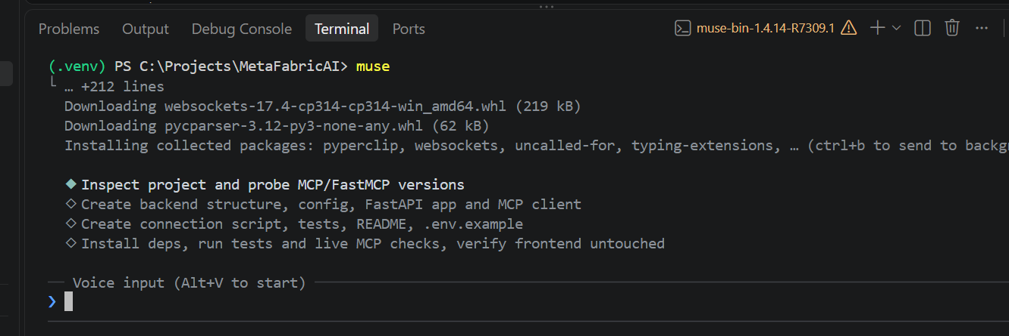
Student concern: Is it safe to not able to understand all those download?

All powershell content after given that prompt:

◆ Ran Get-ChildItem -Force | Select-Object Name, Mode, Length; Write-Host "`n---GIT---"; git status --short; gi… — failed
└ windows_elevated unified exec session launcher unavailable: sandbox enforcement unavailable: Windows sandbox setup un
available: admit deny-read state C:\Users\frank.wang\.local\share\muse\windows-sandbox/deny_read_acl_state.json: host
metadata ancestor permits unproved ACL/owner mutation

◆ Ran command · Inspect project with escalated shell · ✓ · 2m · ctrl+o

◆ Read skill python-env · built-in · 2 KB

Read 2 files · ctrl+o

◆ Ran command · Inspect frontend, python, venv · ✓ · 4.7s · ctrl+o

◆ Read skill durable-test-collateral · built-in · 6 KB

Read 2 files · ctrl+o

◆ Ran command · Check installed packages and PyPI reachability · ✓ · 13s · ctrl+o

◆ Ran command · Verify gitignore and latest PyPI versions · ✓ · 5.4s · ctrl+o

◆ Ran command · Install backend dependencies into project venv · ✓ · 1m · ctrl+o

◆ Ran command · Introspect FastMCP Client API · ✓ · 31s · ctrl+o

◆ Ran command · Probe live Azure MCP tools and schemas · ✓ · 1m · ctrl+o

◆ Ran command · Probe live MCP call result shapes · ✓ · 31s · ctrl+o

◆ Wrote backend/requirements.txt (+8)
1 +fastapi>=0.162.0,<1.0.0
2 +uvicorn[standard]>=0.54.0,<1.0.0
3 +fastmcp>=4.1.4,<5.0.0
4 +httpx>=0.28.1,<1.0.0
5 +python-dotenv>=1.2.4,<2.0.0
6 +pydantic-settings>=2.16.2,<3.0.0
7 +pytest>=9.2.0,<10.0.0
8 +pytest-asyncio>=1.4.1,<2.0.0

◆ Write backend/.env.example — failed
└ Cannot create a file when that file already exists. (os error 183)

◆ Wrote backend/app/__init__.py (+3)
1 +"""MetaFabricAI backend application package."""
2 +
3 +__all__: list[str] = []

◆ Wrote backend/app/config.py (+38) · ctrl+o
1 +"""Environment-based configuration for the MetaFabricAI backend.
2 +
3 +Settings are loaded from environment variables and, for local development,
4 +from ``backend/.env`` (git-ignored). See ``backend/.env.example`` for the
5 +documented variables. No secrets are hard-coded here.
6 +"""
7 +
8 +from functools import lru_cache
9 +from pathlib import Path
10 +
11 +from pydantic import Field
12 +from pydantic_settings import BaseSettings, SettingsConfigDict
13 +
14 +_BACKEND_DIR = Path(__file__).resolve().parents[1]
15 +
16 +DEFAULT_MCP_SERVER_URL = (
17 + "https://ca-metadata-mcp-dev.wittyforest-26c063ae."
18 + "eastus.azurecontainerapps.io/mcp"
19 +)
20 +
… 18 more lines

◆ Wrote backend/app/services/__init__.py (+15)
1 +"""Service layer for the MetaFabricAI backend."""
2 +
3 +from app.services.mcp_client import (
4 + MCPClientError,
5 + MCPConnectionError,
6 + MCPToolError,
7 + MetaFabricMCPClient,
8 +)
9 +
10 +__all__ = [
11 + "MCPClientError",
12 + "MCPConnectionError",
13 + "MCPToolError",
14 + "MetaFabricMCPClient",
15 +]

◆ Wrote backend/app/routers/__init__.py (+3)
1 +"""API routers for the MetaFabricAI backend."""
2 +
3 +__all__: list[str] = []

◆ Ran command · Check existing backend files · ✓ · 4.2s · ctrl+o

◆ Wrote backend/.env.example (+2)
1 +MCP_SERVER_URL=https://ca-metadata-mcp-dev.wittyforest-26c063ae.eastus.azurecontainerapps.io/mcp
2 +MCP_TIMEOUT_SECONDS=60

◆ Wrote backend/app/services/mcp_client.py (+257) · ctrl+o
1 +"""Reusable asynchronous FastMCP client for the Azure Metadata MCP Server.
2 +
3 +Wraps the FastMCP Python SDK (``fastmcp.Client``) over HTTPS. Tool names and
4 +arguments below mirror the server's actual discovered input schemas
5 +(verified live against the Azure endpoint):
6 +
7 +- ``get_metadata_fields``: ``{default_search_only: bool = false}``
8 +- ``get_metadata_field_definitions``: ``{fields: list[str] | null = null}``
9 +- ``get_metadata_catalog``:
10 + ``{fields: list[str] | null = null, offset: int = 0, limit: int = 100}``
11 +- ``get_layer_metadata``:
12 + ``{layer_ids: list[str] (required), fields: list[str] | null = null}``
13 +
14 +No metadata is invented or dropped: results are normalized to plain JSON
15 +values with every server-provided field preserved, including the catalog
16 +pagination fields (``has_more``, ``next_offset``, ``total_records``, ...).
17 +Server-side page limits are respected -- this client never overrides the
18 +``limit`` a caller passes and surfaces the server's pagination markers so
19 +callers can page with ``offset``/``next_offset``.
20 +"""
… 237 more lines

◆ Wrote backend/app/routers/health.py (+44) · ctrl+o
1 +"""Health routers: backend liveness and MCP server connectivity."""
2 +
3 +from fastapi import APIRouter, Depends
4 +from fastapi.responses import JSONResponse
5 +
6 +from app.services.mcp_client import MCPClientError, MetaFabricMCPClient
7 +
8 +router = APIRouter(tags=["health"])
9 +
10 +
11 +def get_mcp_client() -> MetaFabricMCPClient:
12 + """Provide an MCP client instance (overridable in tests)."""
13 + return MetaFabricMCPClient()
14 +
15 +
16 +@router.get("/health")
17 +async def health() -> dict[str, str]:
18 + """Return backend liveness."""
19 + return {"status": "ok", "service": "MetaFabricAI Backend"}
20 +
… 24 more lines

◆ Wrote backend/app/main.py (+33) · ctrl+o
1 +"""MetaFabricAI FastAPI application.
2 +
3 +Step 8 exposes health endpoints and the reusable FastMCP client foundation.
4 +A future Step 9 Muse AI agent can be added under ``app/agents/`` and
5 +mounted here without changing the existing routers or services.
6 +"""
7 +
8 +from fastapi import FastAPI
9 +from fastapi.middleware.cors import CORSMiddleware
10 +
11 +from app.routers import health
12 +
13 +CORS_ORIGINS = [
14 + "http://localhost:5173",
15 + "http://127.0.0.1:5173",
16 +]
17 +
18 +
19 +def create_app() -> FastAPI:
20 + """Create and configure the FastAPI application."""
… 13 more lines

◆ Wrote backend/scripts/test_mcp_connection.py (+134) · ctrl+o
1 +"""Live MCP connection test for the Azure Metadata MCP Server.
2 +
3 +Connects over HTTPS, discovers all available tools, prints their actual
4 +input schemas, calls ``get_metadata_fields``, and retrieves a small
5 +``get_metadata_catalog`` sample. Catalog arguments are built from the
6 +tool's discovered input schema (``limit``/``offset`` when present), never
7 +invented.
8 +
9 +Run from the ``backend/`` folder (with the project virtual environment
10 +active):
11 +
12 + python scripts/test_mcp_connection.py
13 +
14 +Exit code is 0 on success and 1 on any connection/tool failure.
15 +"""
16 +
17 +from __future__ import annotations
18 +
19 +import asyncio
20 +import json
… 114 more lines

◆ Wrote backend/tests/conftest.py (+8)
1 +"""Pytest setup: make the backend ``app`` package importable."""
2 +
3 +import sys
4 +from pathlib import Path
5 +
6 +BACKEND_DIR = Path(__file__).resolve().parents[1]
7 +if str(BACKEND_DIR) not in sys.path:
8 + sys.path.insert(0, str(BACKEND_DIR))

◆ Wrote backend/tests/test_health.py (+120) · ctrl+o
1 +"""Tests for GET /api/health, /docs, CORS, and GET /api/mcp/health.
2 +
3 +Remote MCP calls are mocked -- these tests never touch the Azure server.
4 +"""
5 +
6 +from fastapi.testclient import TestClient
7 +
8 +from app.main import app, create_app
9 +from app.routers.health import get_mcp_client
10 +from app.services.mcp_client import MCPConnectionError, MCPToolError
11 +
12 +client = TestClient(app)
13 +
14 +
15 +class FakeMCPClient:
16 + """Stand-in MCP client returning fixed discovered tools."""
17 +
18 + server_url = "https://example.invalid/mcp"
19 +
20 + async def health(self):
… 100 more lines

◆ Wrote backend/tests/test_mcp_client.py (+190) · ctrl+o
1 +"""Unit tests for MetaFabricMCPClient with a mocked FastMCP transport.
2 +
3 +No network access: a fake client factory stands in for ``fastmcp.Client``.
4 +"""
5 +
6 +import pytest
7 +
8 +from app.services.mcp_client import (
9 + MCPConnectionError,
10 + MCPToolError,
11 + MetaFabricMCPClient,
12 + normalize_tool_result,
13 +)
14 +
15 +
16 +class FakeTool:
17 + def __init__(self, name, input_schema):
18 + self.name = name
19 + self.description = f"{name} description"
20 + self.input_schema = input_schema
… 170 more lines

◆ Wrote backend/README.md (+200) · ctrl+o
1 +# MetaFabricAI Backend (Step 8)
2 +
3 +FastAPI backend and reusable asynchronous FastMCP client for the Azure
4 +Metadata MCP Server. This step is foundation only: it does **not** implement
5 +the Meta Muse AI agent (Step 9), does not connect the React frontend, and
6 +does not duplicate the metadata catalog.
7 +
8 +```text
9 +Citizen -> React Web App (Step 7, unchanged)
10 + -> Meta Muse AI Agent (Step 9, not in this step)
11 + -> FastAPI backend (this folder)
12 + -> FastMCP client -> Azure Metadata MCP Server -> Open Data Catalog
13 +```
14 +
15 +## Structure
16 +
17 +```text
18 +backend/
19 +├── app/
20 +│ ├── __init__.py
… 180 more lines

◆ Ran command · Copy env, verify ignores and structure · ✓ · 20s · ctrl+o

◆ Ran command · Run backend pytest suite · ✓ · 32s · ctrl+o

◆ Wrote backend/pytest.ini (+4)
1 +[pytest]
2 +asyncio_default_fixture_loop_scope = function
3 +asyncio_default_test_loop_scope = function
4 +testpaths = tests

◆ Ran command · Rerun tests and live MCP script · ✓ · 12s · ctrl+o

◆ Ran command · Start backend, verify live endpoints, stop it · ✓ · 23s · ctrl+o

◆ Step 8 is complete. Live MCP connectivity succeeded, all 18 automated tests pass, and the React frontend is untouched.

Live MCP connectivity: YES ✅

Verified directly against the Azure server and through the running FastAPI backend:

• Discovered 4 tools: get_metadata_fields, get_metadata_field_definitions, get_metadata_catalog, get_layer_metadata
• get_metadata_fields returned 33 fields (Always Search: AssignedID, Title, LayerList, Summary, Description, Tags)
• get_metadata_catalog sample: 1,660 total records, has_more: true, next_offset: 5
• Real HTTP check: GET /api/health → {"status":"ok","service":"MetaFabricAI Backend"}; GET /api/mcp/health → 200 with
the 4 actual tool names; /docs → 200; CORS header confirmed for http://localhost:5173 (test server was started,
verified, then stopped)

No real errors occurred. All tool arguments in the client mirror the server's actual discovered input schemas — nothing
was invented.

Created files
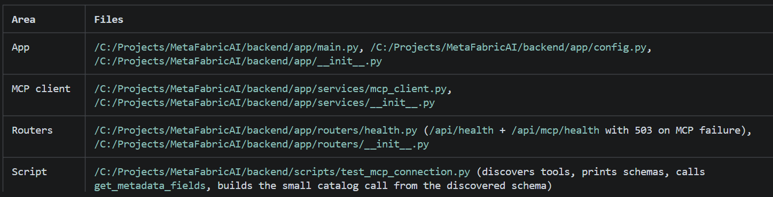
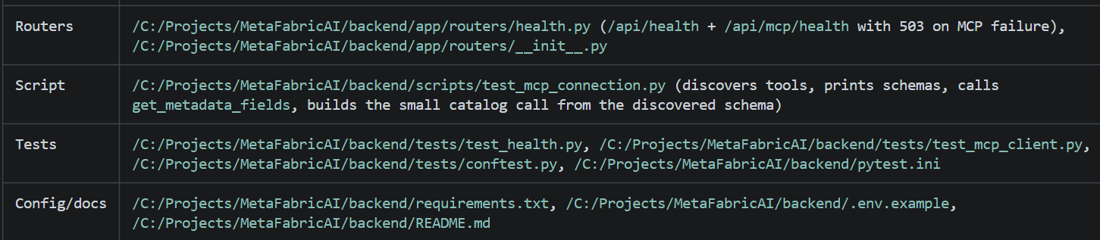
Also created locally: backend/.env (copy of .env.example, git-ignored) and installed packages into the existing
project-root .venv. No root files were modified — the root /C:/Projects/MetaFabricAI/.gitignore already ignores .env
and .venv/ at every level (verified with git check-ignore). No app/agents/ was created; the structure is ready for it
in Step 9.

Backend structure

backend/
├── app/
│ ├── __init__.py
│ ├── main.py # FastAPI app, CORS (localhost:5173), /api mounting
│ ├── config.py # pydantic-settings: MCP_SERVER_URL, MCP_TIMEOUT_SECONDS
│ ├── services/
│ │ ├── __init__.py
│ │ └── mcp_client.py # MetaFabricMCPClient: list_tools, call_tool,
│ │ # 4 metadata wrappers, JSON normalization,
│ │ # MCPConnectionError / MCPToolError, pagination preserved
│ └── routers/
│ ├── __init__.py
│ └── health.py # GET /api/health, GET /api/mcp/health
├── scripts/test_mcp_connection.py
├── tests/ (conftest.py, test_health.py, test_mcp_client.py)
├── pytest.ini
├── requirements.txt
├── .env.example
├── .env # local only, git-ignored
└── README.md
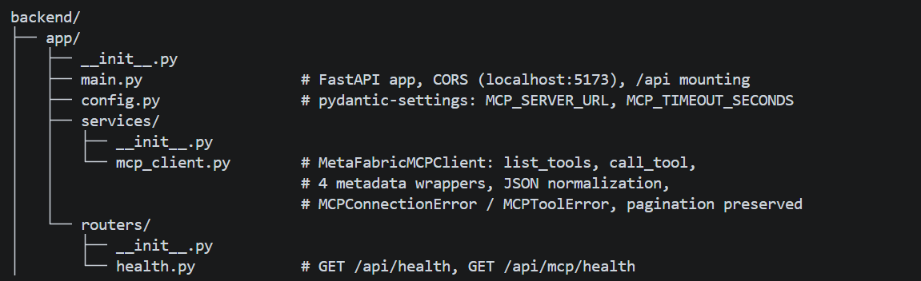
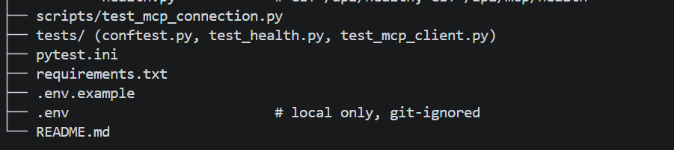
Dependencies pinned to versions verified on Python 3.14.10: fastapi>=0.162,<1, uvicorn[standard]>=0.54,<1,
fastmcp>=4.1.4,<5 (installed 4.1.4), httpx>=0.28.1,<1, python-dotenv, pydantic-settings, pytest, pytest-asyncio.

Tests run

18 passed in 2.87s

Coverage: exact /api/health response, /docs, CORS allow/deny, MCP health success (actual tool names) and 503 handling
for connection + tool errors (all MCP calls mocked), client argument passing for all four tools, pagination
preservation (has_more/next_offset/all fields kept), JSON normalization, and error wrapping. frontend/ shows zero
changes in git status; the pre-existing modified/untracked files under doc/ were left exactly as found.

Exact PowerShell commands

cd C:\Projects\MetaFabricAI
python -m venv .venv # skip if .venv already exists
.\.venv\Scripts\Activate.ps1
python -m pip install -r backend\requirements.txt
Copy-Item backend\.env.example backend\.env # already done locally

# Run the backend
cd C:\Projects\MetaFabricAI\backend
..\.venv\Scripts\Activate.ps1
python -m uvicorn app.main:app --reload --host 127.0.0.1 --port 8000
# Then open http://127.0.0.1:8000/docs

# Tests and live MCP check
python -m pytest tests -v
python scripts\test_mcp_connection.py

Step 9 can now build the Meta Muse AI Agent on MetaFabricMCPClient (e.g. in backend/app/agents/) without changing this
foundation.

◆ Worked for 11m 36s · 3:39 PM · 31/Oct

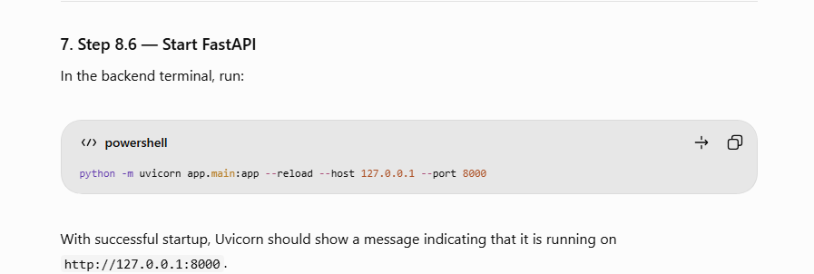
python -m uvicorn app.main:app --reload --host 127.0.0.1 --port 8000
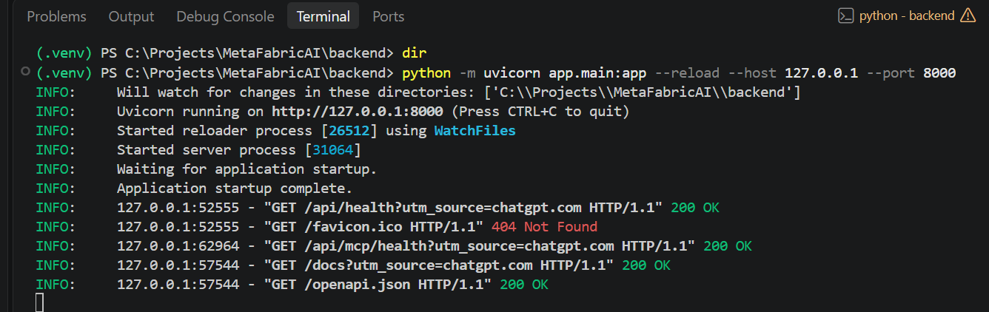
Test 1 — FastAPI health
http://127.0.0.1:8000/api/health
Verifies that your backend is running.
Test 2 — Azure MCP health
http://127.0.0.1:8000/api/mcp/health
Checks whether the Azure MCP connection works.
Test 3 — API documentation
http://127.0.0.1:8000/docs
Shows the generated FastAPI documentation.
Client
http://localhost:5173

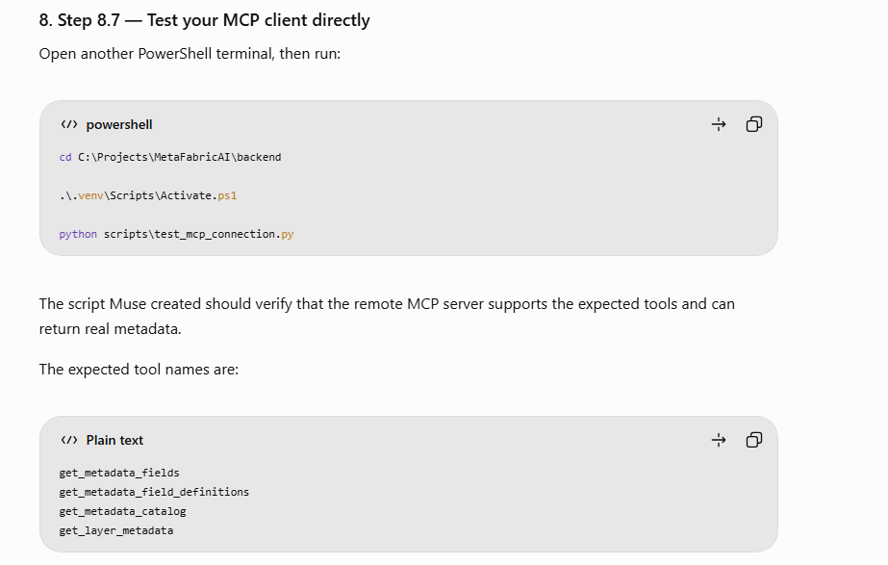
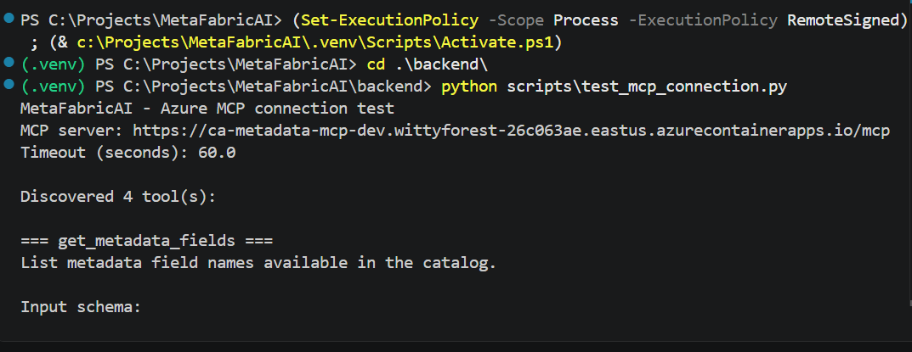

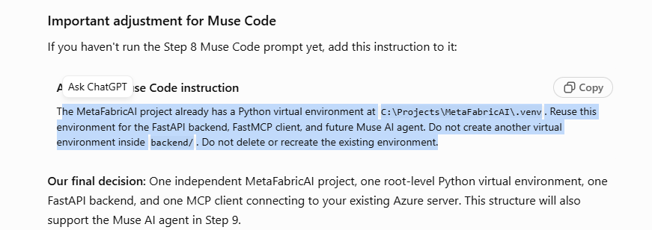
The MetaFabricAI project already has a Python virtual environment at C:\Projects\MetaFabricAI\.venv. Reuse this environment for the FastAPI backend, FastMCP client, and future Muse AI agent. Do not create another virtual environment inside backend/. Do not delete or recreate the existing environment.

